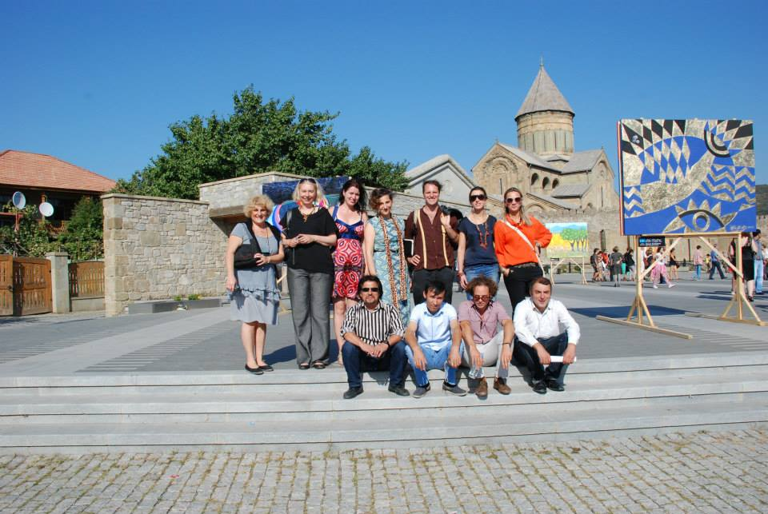

Paint For Georgia Application 2018

First name: ……………………………………………………………………………..
Last name: .……………………………….……………………………
Address: .……………………………….……………………………
Date of birth, place, country: .……………………………….………………………
Phone: ……………………………………………………….…….
Mobile: …………………………………………………….…….
Website: …………………………………………………………………………………
Email: ……………… ……………………..….

What art form/s does it involve?
………………………………………………………………………………………………

Why would you like to be part of Art festival Paint for Georgia ?
………………………………………………………………………………………………
………………………………………………………………………………………………
………………………………………………………………………………………………
………………………………………………………………………………………………
………………………………………………………………………………………………
………………………………………………………………………………………………

Forward applications to:
email: g.tabliashvili@yahoo.com

VOICE FROM GEORGIA
4 Kutateladze str
Tbilisi Georgia.

If you need any further information contact: +995 599 963 789

email: g.tabliashvili@yahoo.com

What Voice From Georgia is offering you:

Hotel-Bedroom with bathroom. (400 Eu Paid by the artist: 5 nights)
Wireless internet.

Workshop
Exhibition

3 time meals per day

2 tours to historical places of Georgia

Painting materials: Canvas, Brushes, Acrylic paints.

